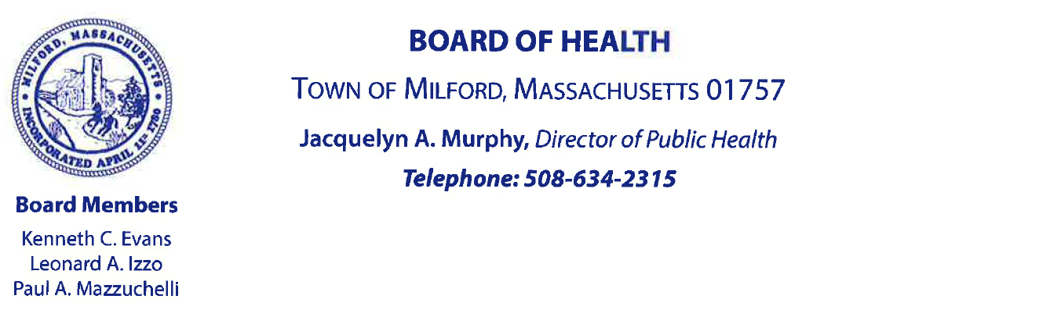

Board of Health Meeting – April 6, 2022 @ 6pm in Town Hall, Room 14
Call Meeting to Order
Chair Paul Mazzuchelli called the meeting to order at 6:00pm.
Approve minutes from March 8, 2022 meeting
The minutes were approved unanimously. Motion made by Leonard Izzo, seconded by Ken Evans.
Re-appointment of staff
The following reappointments for the upcoming fiscal year were endorsed unanimously. The motion was made by Paul Mazzuchelli and seconded by Ken Evans:
- Meeting Clerk – Lisa Tamagni
- Soil Evaluator – Michael Catalano
- Assistant to Health Agent / Title 5 – Michael Dean
- Nurse – Mary Watson
- Physician – Felix Perriello, MD
- Dental Assistant – Judy Dagnese
- Departmental Clerk – Vacant
- Board of Health Officer / Agent – Jacquelyn Murphy
- Health Inspector – Joan Clarico
- Assistant Director – Lisa Tamagni
- Health Inspector – Hannah Tavares
- Burial Agent – Lisa Tamagni
- Person to Report Contagious Disease – Paul Mazzuchelli
Election of Chairman
Leonard Izzo was elected the new chair of the Board of Health. Paul Mazzuchelli made the motion, and Ken Evans seconded the motion. Leonard Izzo accepted the nomination, and then he assumed the duties of chair of the meeting.
Central Gas & Market – Tobacco Permit
The Central Gas & Market has been closed for repairs. At the meeting, Mr. Kevin Ribeirio represented the family. He requested that their permit be reinstated since it is one of their biggest sellers and they did not renew it previously since they had been closed.
Mr. Ribeirio discussed that the family is now the only owner/employee team, rather than the partners they previously were working with who he said violated the terms of their alcohol permit.
Mr. Izzo asked if they would also be selling gas. Mr. Ribeirio said not at this time but maybe in the future.
Mr. Mazzuchelli noted that every tobacco permit holder has compliance checks periodically to ensure they are following all terms of their tobacco permit, including such things as checking identification.
Mr. Izzo noted that all employees needed education and training about proper procedures for selling tobacco.
Mr. Ribeirio stated that his family are the only employees and all are trained and aware of proper tobacco sales processes, and he stated that if they hired other employees in the future, they would train them as well.
At the conclusion of the conversation, Mr. Mazzuchelli made a motion to approve the tobacco permit for Central Gas & Market. Mr. Evans seconded the motion, and it was approved unanimously.
Mr. Ribeirio planned to go to the Board of Health office the following day to pay for and pick up his permit.

Rubbish & Recycling Contract FY23
The current contract ends June 30, 2022 with EL Harvey with the option to extend for a fourth year.
The board members discussed the following process with two representatives from EL Harvey, Mr. Michael Szczepan and Mr. Benjamin Harvey:
Effective July 1, 2022, no more bulk items will be picked up curbside. Residents will have to call EL Harvey directly for all bulk item pickups. There will be a separate charge for bulk item disposal.
The Board of Health will discuss with Town Counsel the possibility of removing multi-family homes with four or more units from trash and recycle pickup with the Town. This would start July 1, 2023. The intention of this change is to ensure that residential trash and recycle curbside pickup can still be a cost funded by the town taxes. For property owners of these large dwellings, which are economically profitable, it would be their responsibility to obtain a dumpster or other private trash and recycle service.
Also effective during fiscal year 2023, the Board of Health will seek additional town funding to purchase Toters (i.e., 96-gallon wheeled plastic bins with attached lids). Each dwelling would get two Toters – one for trash and one for recycle. The Town would enter a lease-to-own agreement with EL Harvey, purchasing these Toters over a period of 10 years. During the 10 years, EL Harvey replaces/repairs the Toters as needed. After the 10 year contract is up, the Town owns/replaces/repairs the Toters as needed.
Finally, to reconcile cost discrepancies from earlier tonnage bills, the representatives from EL Harvey agreed to a reduction of $21,548.42 from the hauling fee paid in the upcoming three months.

Upcoming COVID-19 Clinics
Recently, the BOH has hosted booster clinics, after the FDA and CDC recommended that all adults age 50 and older as well as anyone who is over 12 with certain immunocompromising conditions get a second booster shot.
Earlier on April 6, the Board of Health hosted a clinic at the Senior Center and vaccinated 42 people.
There will be a clinic on April 12, hosted in upper Town Hall.
There will also be a clinic on April 26, hosted at Birmingham Court.

