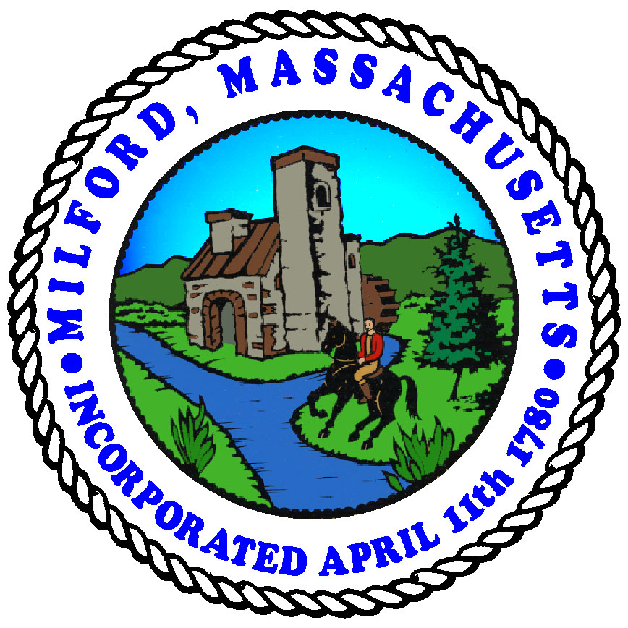
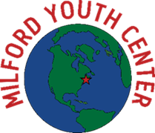
TOWN OF MILFORD, MASSACHUSETTS
MILFORD YOUTH CENTER
MILFORD YOUTH COMMISSION
24 Pearl St., Milford, MA 01757
(508) 473-1756 Phone
(508) 473-4388 FAX

Milford Youth Commission
Virtual Meeting
Date: December 13, 2022
Time: 6:15pm

Pursuant to Chapter 20 of the Acts of 2021 Act Extending Certain COVID-19 Measures Adopted during the State of Emergency, which Act extends Governor Baker’s March 12, 2020 order suspending certain provisions of the Open Meeting Law, G.L. c. 30A sec. 18, this meeting is being conducted partially via remote participation. Every effort will be made to ensure that the public can adequately access the proceedings as provided for in the Order. Where active real-time participation by members of the public is a specific legal requirement, means of public access will be provided. Any member of the public may view the zoom meeting LIVE at: http://tiny.cc/8ap1vz

Members Present: Darlene Dulude, John Dulude
Members Remote: Brendan Rickert, Ariea Bryan, Chuck Calagione, Sandra Caproni, Christine Crean,
Stacy Darling
Members Absent: Steve Sousa, Jason Vaz
MYC Staff Present: Emily Stienstra, Jen Ward
Staff: Dale Michaud

Call to Order
At 6:18 pm, Chair Rickert called the meeting to order, read the Open Meeting Law Statement, and performed the roll call.

- Invitation to Speak: None.
- New Business
  - Approve Meeting Minutes: 11/1/22

Motion: B. Rickert moved to approve the meeting minutes of 11/1/22.
Seconded: S. Caproni
Roll Call Vote: A. Bryan, C. Calagione, S. Caproni, C. Crean, S. Darling, D. Dulude, J. Dulude, B. Rickert. None opposed.
Motion Carries: 8-0

  - Fund Balance as of 11/30/22: $ 75,201.81
Thanks to Ms. Darling's employer contribution, Raytheon matched $ 1,000.

  - Signing of warrants:
  - 23-19 Revolving Account for $ 243.63 (pizza/mileage from Pizza Palace for Halloween volunteers)
  - 22-19 Maintenance Account for $ 19.99 (MYC website domain cost for the year)
  - 23-20 Revolving Account for $ 350.00 (DJ for the year)
  - 23-21 Maintenance Account for $ 85.04 (Fish food and tank maintenance)
  - 23-22 Holiday Gift Account for $ 233.74 (Holiday gifts for volunteers)
  - 23-23 Revolving Account for $ 339.50 (2nd installment of AmeriCorps social capital)
  - 23-23 Gift Account for $ 3,750.00
(Ms. Stienstra's mileage reimbursement, Thanksgiving needs for After-school program from Oliva's Market and Stop n Shop)

Motion: B. Rickert moved to approve the meeting minutes of 10/17/22.
Seconded: J. Dulude
Roll Call Vote: A. Bryan, C. Calagione, S. Caproni, C. Crean, S. Darling, D. Dulude, J. Dulude, B. Rickert. None opposed.
Motion Carries: 8-0

  - Safety issues at crosswalk – messaged Police 8/10/22 & 10/19/22
- Hit & Run Incident 11/28/22
Members discussed the incident where an MYC After-School youth member was hit by an automobile whose driver left the scene of the accident. Members discussed proactive actions taken by MYC Director, J. Ward, to schedule a meeting of Community leaders to address the incident, risk of life and limb, and future remedies.

Ms. Ward contacted the District Attorney's office of Rick Molani as well as the offices of the Milford Highway Administrator and Milford Police Chief but no meeting has been scheduled.
- Police Chief assigned two police cruisers to both sides of the crosswalk for afternoon pick-up.
- Speeding drivers paid no attention to the police cruisers.
- In the past, Police have said drivers are not speeding fast enough to warrant citations.
- In the past, MYC Director and two MYC Board members saw a child almost hit by a car.

Members discussed remedies they have employed the last few years to slow cars down:
- Made the MYC driveway a one-way driveway
- Painted the driveway and put up signs.

Members discussed future remedies in lieu of the Town leaders coordinating a response:
- Hire a crossing guard to keep children safe such as for the schools.
- Consider utilizing a volunteer to stand at the crosswalk with youth members.
- Utilizing a volunteer or staff member would detract from safety needs at the Center.
- Consider utilizing community youth to stand at the crosswalk with youth members.
- Add more signage to place out in the road.
- Waiting on a meeting with the Town.
- Add a graduated, permanent hump to the roadway.
- Purchase the green, plastic "children at play" figures with the orange flags. Place them out when the MYC is open. Remove the figures when the MYC is closed.
- The former Police Chief told the MYC Director not to use the green, plastic figures.
- Members discussed the urgency of protecting the children now with signage.

- Vote on purchasing additional signage

Motion: J. Dulude moved to authorize MYC to spend up to $500 on signage for crosswalks.
Seconded: C. Crean
Roll Call Vote: A. Bryan, C. Calagione, S. Caproni, C. Crean, S. Darling, D. Dulude, J. Dulude, B. Rickert. None opposed.
Motion Carries: 8-0

  - New Custodian, Gregory Yanovitch started 12/5/22
- MYC staff reported he is doing a great job, keeps open communication. Everyone is pleased.
- MYC Board member and volunteer, Jay Vaz, was recognized for fulfilling the custodial role for three months although he had been promoted in his Town position and was busy. He was recognized for his commitment to the Youth Center.

- Directors Report:
- After School Program:
  - After School Calendar attached
- Fun holiday, spirit week activities consistent with signups for after-school programs
- The Lifeskills program in its third month is going strong.
- Drug Prevention presentation by a representative from District Attorney's office.
  - Parents signed up and attended.
  - Attendance is high!
  - Attendance, dinner and snack numbers: November 2022
Ms. Stienstra reviewed the numbers.
  - School calendar and fliers attached
  - Lovin’ Spoonfuls – weekly groceries starting 12/9
- Partnership about food rescue.
- Go around to different grocery stores to prevent waste.
- MYC received the first distribution of 200 pounds of food
- Distributed the distribution to 16 families who signed up for the first week.
- This will be a weekly program
  - YMCA Pop Up Pantry – Once/month starting in January
- Pop up pantry once per month across the street
- Families grab additional food at no cost
- MYC management to meet with Parks Director, Jim Asam, for dates so every department is aware of the program and dates.

- Building Updates:
  - Renovation litigation: See 11/10/2 email
    - Gym Floor relief cut to be done 12/26/22
- Members discussed the condition of the buckling Gym floor which was not done according to building code.
- The attorney the Town hired is in communication with Brian Murray as well as the MYC Director and Facilities Director.
- Gym floor will be fixed on 12/26. They will do relief cuts. If that doesn't work, MYC will ask for additional funds to fix the Gym floor.
    - Waiting on agreement to do Lobby floor
- Waiting for quotes on lobby floor for some work done incorrectly.

    - Outside work to start in Spring on April 3rd

  - Music/Multipurpose Media Center- bid documents are ready and waiting on new Town Engineer – emailed 10/31, 11/7, 11/22, 12/6

  - HVAC project in progress –Health Foundation of Central Massachusetts Meeting grant for $115,250.00 – contract signed
- Contract signed so grant could be incorporated into current HVAC project.
- MYC Director met Rick Villani, Jay Vaz, and Carlos Benjamin and wrote work into the grant.
- MYC existing HVAC already performs some of what was written into the grant
- There may be extra funds left over.

- Donation/Grant Updates:
  - See newsletter for monthly updates for miscellaneous donations: https://conta.cc/3gRnatY
  - Thanksgiving Event Recap!
- MYC fed 115 kids, 20 adults, and invited Town Hall special guests.
- This was the first time in 3 years they did this.
- There was so much support from the community as well as monetary donations from 4 MYC Board members: Mr. & Mrs. Dulude, Ms. Darling, S. Caproni
- Greenleaf Garden Club did a craft with the kids.
  - Giving Tuesday Recap!
- Ms. Darling secured a $ 1,000 MYC donation matched by Raytheon.
- MYC raised $ 2,600 for the day with the $ 1,000 donation!
  - Santa Parade Recap!
- Biggest Santa Parade ever. Kids pointed out MYC Staff wearing matching pajamas and came over to the MYC to say, "we saw you". It was a bonding moment for MYC Staff.
  - Holiday Sponsorships: 121 children supported
    - United Way of Tri-Country – 60 youth
    - Amazon – 30 youth (and basketballs)
    - Waters Corp. – 15 youth
    - West St. Autobody – 4 youth
    - MassCor Industries – 4 youth NEW VOMMUNITY PARTNERSHIP
    - GoldFish Swim School – Collection
    - Barbell 88 with Lunas' Place – Collection NEW COMM PARTNERSHIP
    - Miscellaneous individuals: Mary Pratt, Carly Fauth, Olga Doktorov, Brit Roy,
Kayte Lenahan, Alyssa Bibeau
  - Milford Regional Partnership secured!
- They will send $ 250 monthly to support programs.

- Other Events:
  - YMCA Golf Tourney – Friday, May 5, 2023 (Cinco de Mayo)
    - Shining Rock Golf Course, 91 Clubhouse Lane, Northbridge, MA 01534
    - 8:30 am start with lunch around 2:00 pm
    - Current Committee: Jen Ward, Ken Rosa, Jim Downs (CEO), Pat Murphy (Association Director Community Engagement & Partnerships)
    - Help from Youth Commission:
      - 1-2 members on committee
      - Securing foursomes
      - Sponsorships (t-signs)
      - Day of event help
    - YMCA will help with planning, marketing, etc. (see shared docs)
  - YMCA to do legwork
    - Funding will come from sponsors
    - They hope to secure the presence of Patriots' football players
  - Need 1-2 MYC Board members to be on the committee
    - MYC Board member, C. Crean volunteered
  - Need MYC Board and Staff to help with foursomes on event day.
    - MYC Board member, B. Rickert volunteered
- Need foursomes and sponsors!!!
  - Documents are in this meeting packet.

- Rentals:
  - Rental contract edits: CORI needed for applicant – response from Town Council update
- MYC management met with Town Council
- If the renter is not directly associated with an organization which runs a CORI, MYC will run the CORI.
- The MYC Renter form was approved to incorporate into MYC contracts starting 1/1/23.

As of 1/1/23, MYC has secured one rental per day with an estimated income of $10,000.
- With Adult Open Gym, there are 10-15 former MYC youth who are now adults reconnecting and participating in MYC activities.

  - Current and future rentals/MYC programs: https://tinyurl.com/MYCrentals

- Next Meeting: Tuesday, January 10, 2023 @ 6:15
Establish a 2023 calendar for future meetings on the second Tuesday of the month.

Documents used
- Meeting Minutes 11/1/22 | - MYC Funds Report
- 11/10 Murray Law email Milford/RAC Damages and Demand | - MYC December Calendar  - MYC Attendance for After-School, Snack, Dinner
- Flyer, Lovin' Spoonfuls Food Distribution | - Hockomock YMCA Hole-in-One Golf Tournament Rules
- Hockomock YMCA 50 Foot Putt for Cash Golf Tournament Rules | - Hockomock YMCA Golf Tournament Sponsor List
- Hockomock YMCA Golf Green Agenda | - Golf Tournament Potential Revenue Report

Adjourn
Motion: B. Rickert moved to adjourn the meeting at 7:15 pm.
Seconded: S. Caproni
Roll Call Vote: A. Bryan, C. Calagione, S. Caproni, C. Crean, S. Darling, D. Dulude, J. Dulude, B. Rickert. None opposed.
Motion Carries: 8-0

Respectfully submitted,
Dale Michaud, Recording Secretary

The listing of matters above are those reasonably anticipated by the Chair which may be discussed at the meeting. Not all items may be discussed, and other items not listed may also be brought up for discussion to the extent permitted by law.

________________________________ ____________________
Brendan Rickert Date

